Sprint 1

Jira will be updated as we go along, and all information/data shall be tracked. This page shall show some insight into sprint 1 and record how it went.

**Monday 17th Feb 2020**

All user stories taken from the product Backlog to create the sprint plan

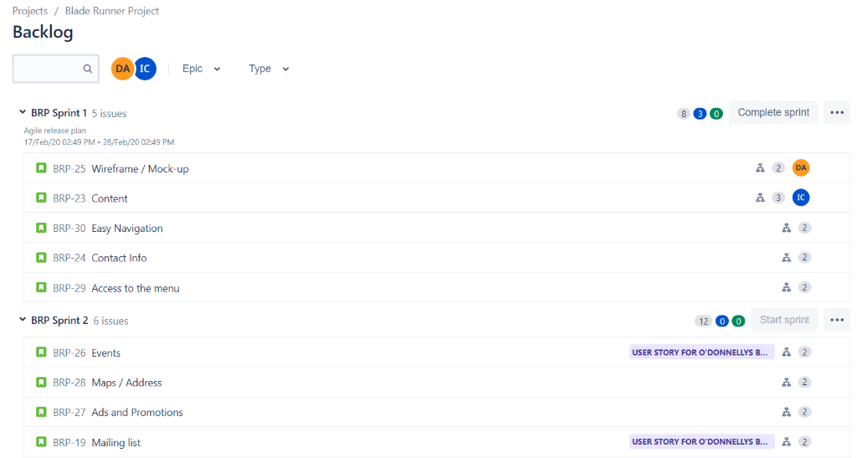

The sprint is in progress  and all tasks have been broken down into smaller tasks.

**Wednesday 19th Feb 2020**   
Team members are assigning themselves tasks. With the sections of to do, in progress and done, all tasks are trackable. As with the definition of Ready and Done. Our first user story is complete.

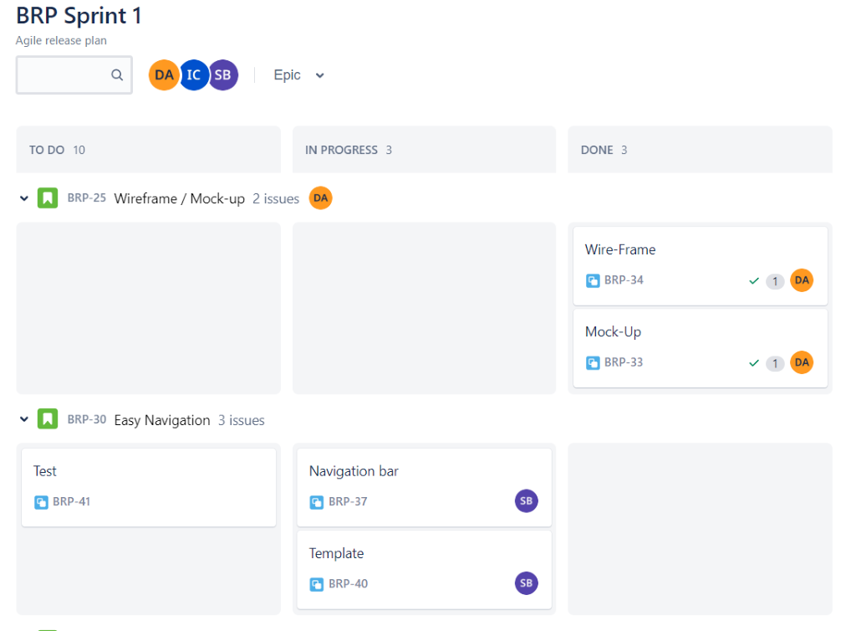

**Thursday 20th Feb 2020**

Additional tasks have been updated to completed and in progress.

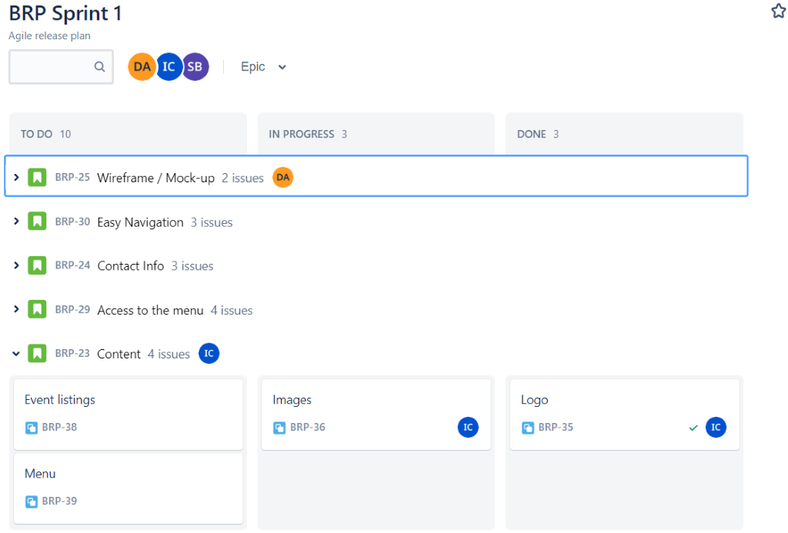

**Thursday 27th Feb 2020**

Members forgot to update Jira as each task was completed, meaning they all got updated near the end of the sprint, causing inaccurate data. The tasks were associated to the member that worked on it.

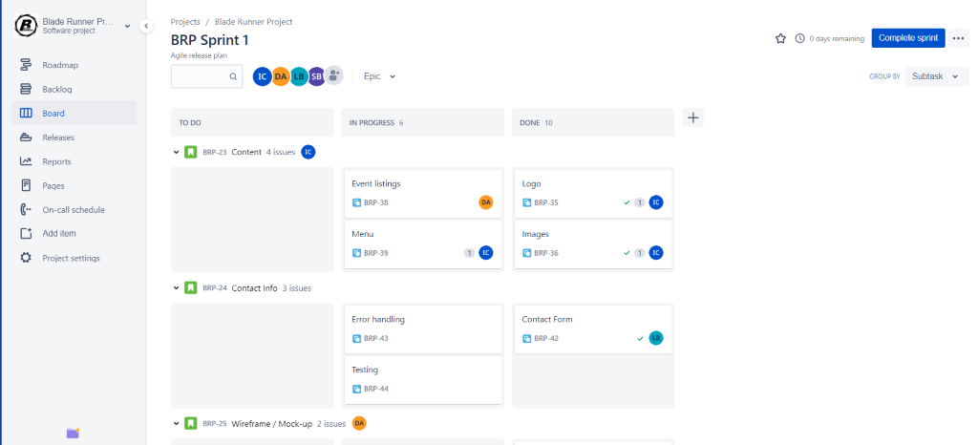

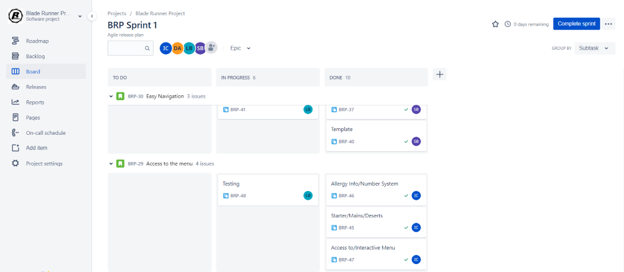

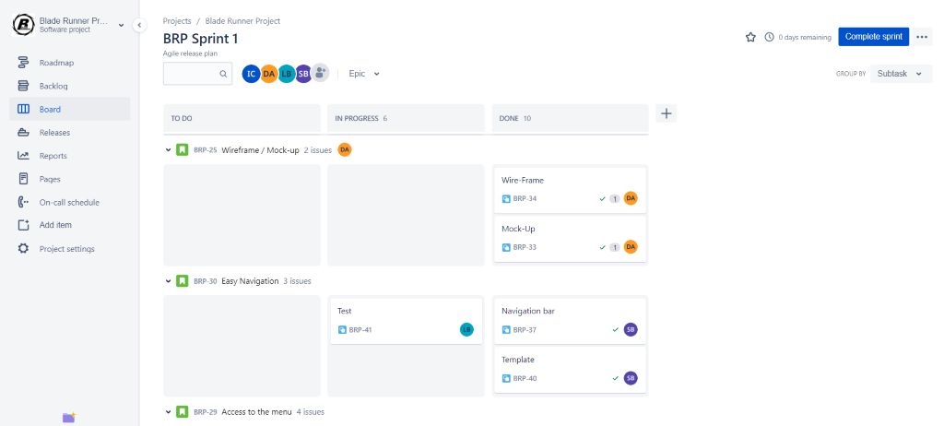

**Friday 28th Feb 2020**

Instantly from in progress the tasks went to complete. Skewed data.

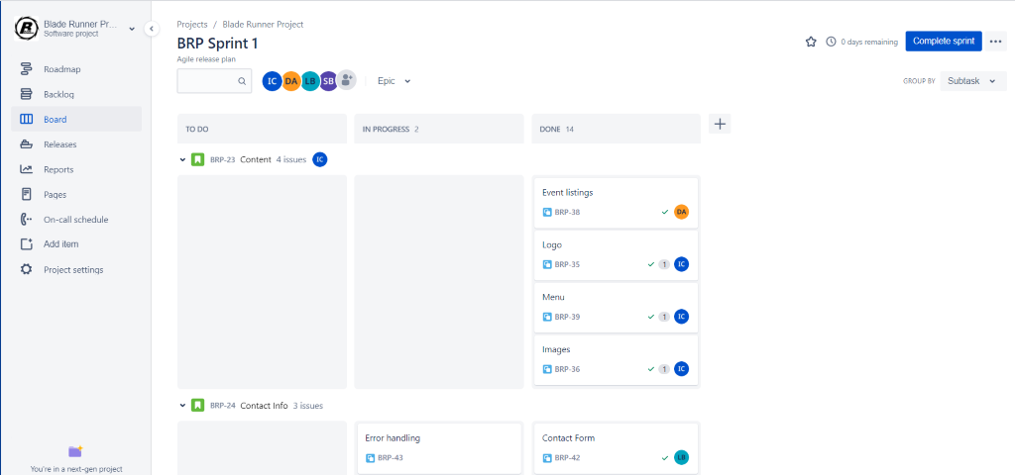

One task was not completed in sprint 1.  data handling wasn’t completed and fully tested. It was brought up in the sprint review and as part of our retrospective it'll added to sprint 2 without any scope issues.

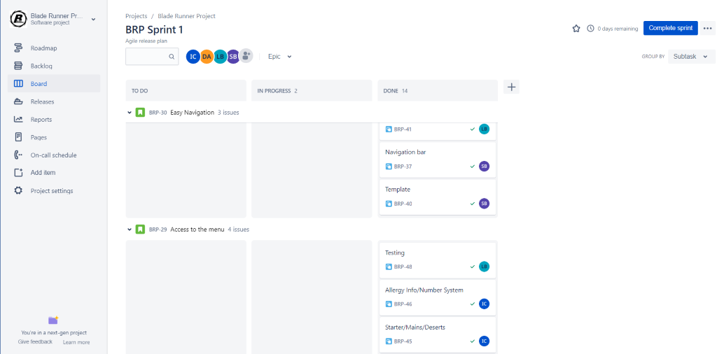

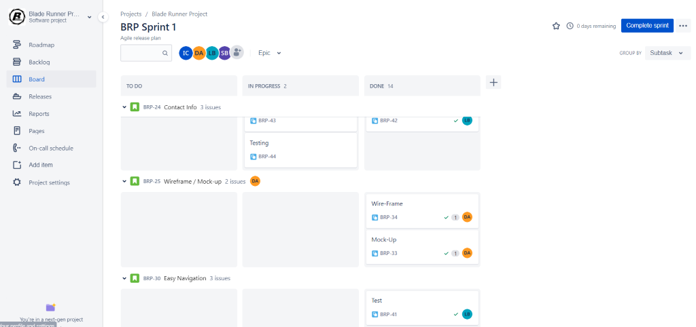



------------------------------------------------------------------------------

**Burndown Chart Sprint 1**

Unfortunately, as the tasks were not updated as they were done. It created a big fat lie and our data was skewed. Meaning the burndown chart was not a true reflection on what occurred.

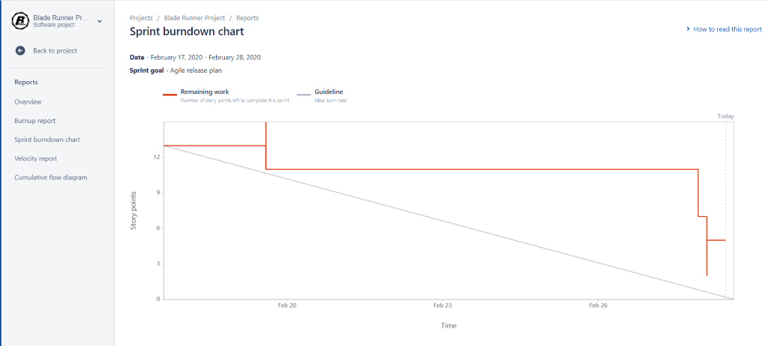

**Cumulative Flow Diagram**

Shows the tasks were updated last minute and the flow diagram shows that perfectly.

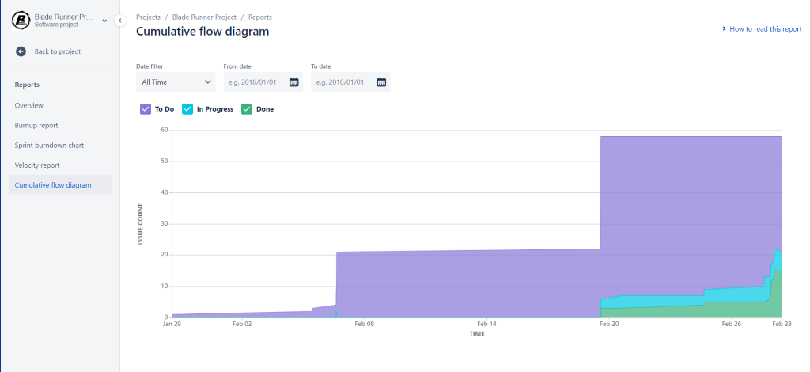

**Sprint 1 Ends**

Jira was a learning curve but proves there a process to everything and each stage needs to be followed otherwise you have no data to show at the end of it. We can adapt from our mistakes in sprint 1 and improve the results of sprint 2.